RMIT University

Assignment Cover Page (INDIVIDUAL)
Subject Code: | COMM2333
Subject Name: | Client management
Location & Campus where you study: | Melbourne
Title of Assignment: | A1 Case Insights Report: this is an Individual assessment
Student name: | Le Phuong Dung Hoang
Student Number: | S3957038
Teachers Name:

Group Number:

Assignment due date: | 17/4/2024
Date of Submission: | 17/4/2024
Number of pages including this one:

Word Count: | 1540
Declaration of Authorship:  Make sure to read the Assessment Declaration https://www.rmit.edu.au/students/studentessentials/assessment-and-exams/assessment/assessment-declaration | I declare that in submitting all work for this assessment I have read, understood and agree to the content and expectations of the Assessment Declaration
Consent to Use (KEEP ONLY ONE SENTENCE): | - I do NOT give RMIT University permission to use my work  - I give RMIT University permission to use my work as an exemplar and for showcase/exhibition display. This consent will remain valid till________________ (Specify the expiration date of such consent)

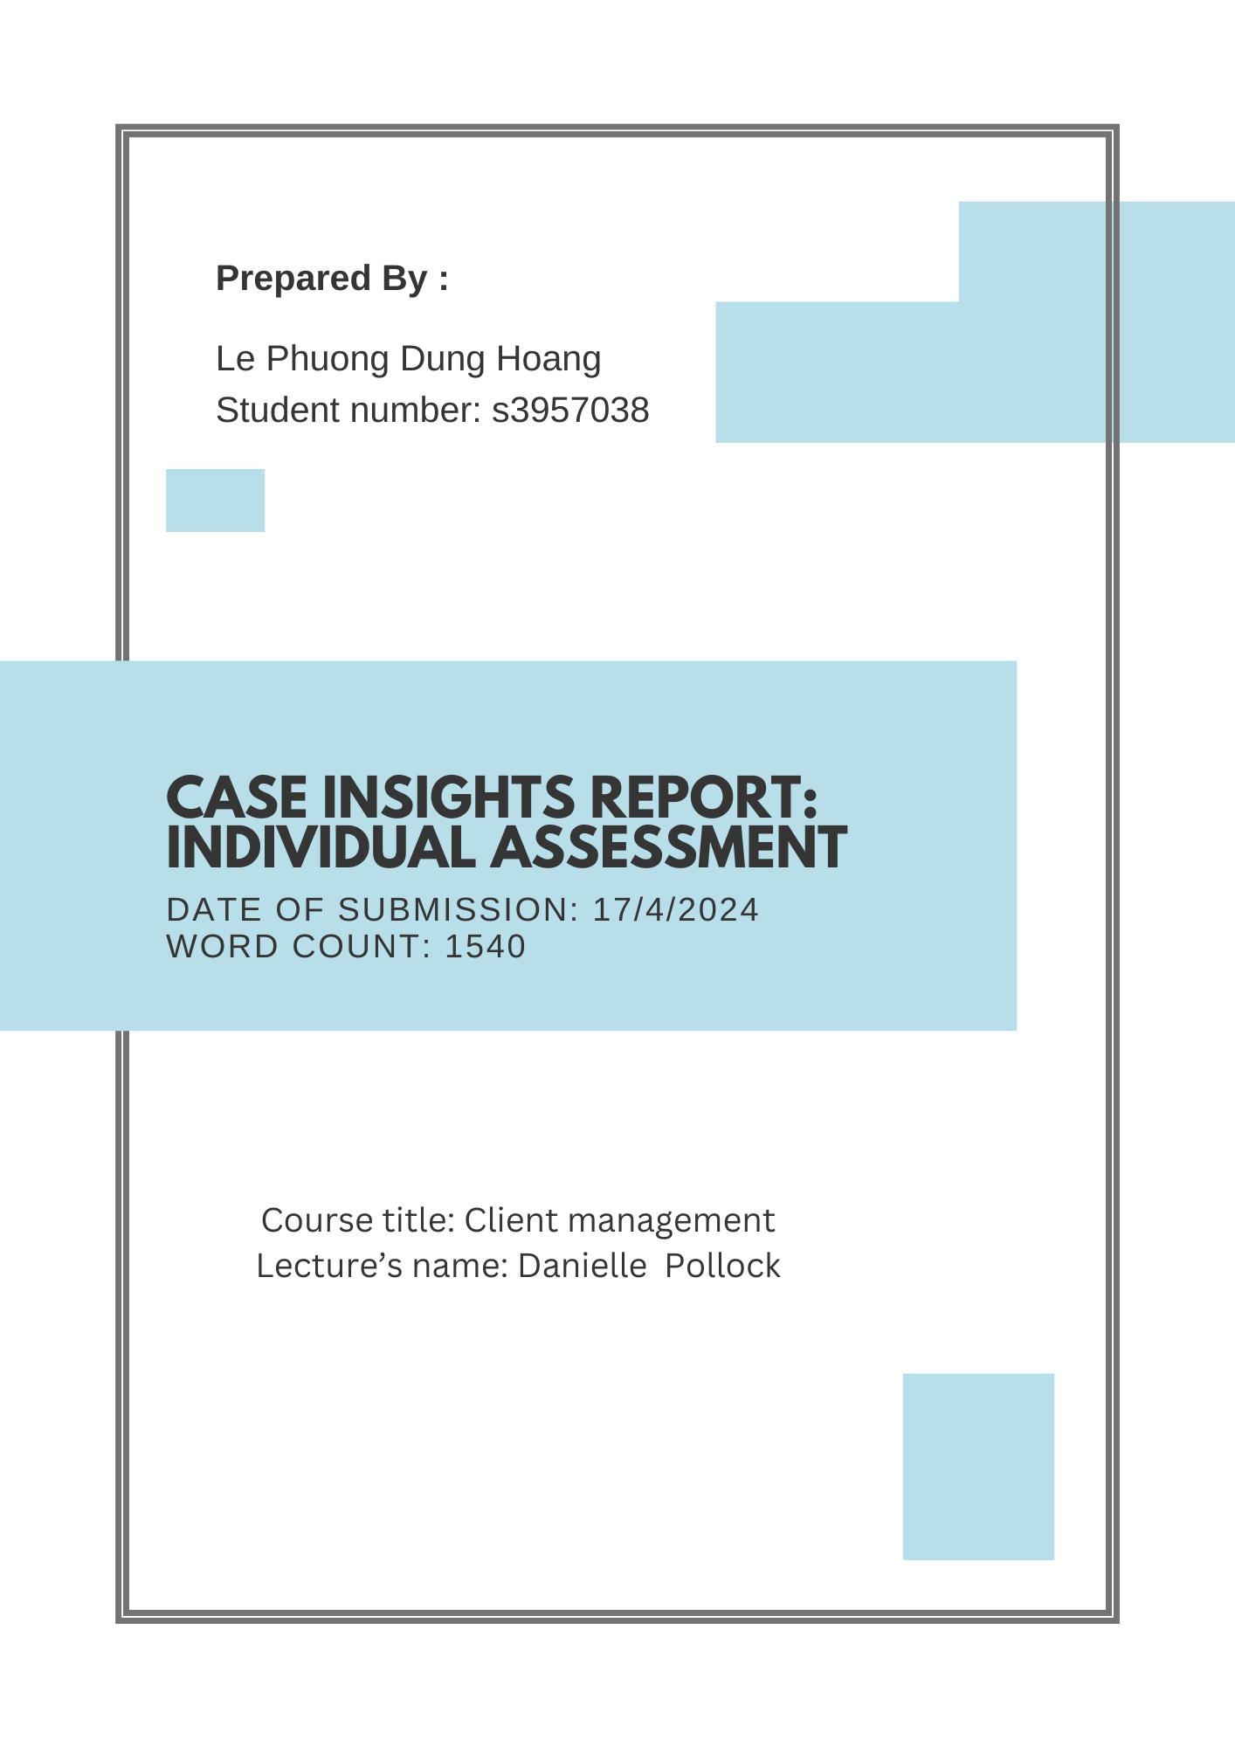

Executive summary
This report examines insights from case studies in client management within the advertising industry, utilising the DEA method. Findings underscore the significance of diversifying client bases, efficient delegation, and expense management. Recommendations advocate for their implementation while suggesting further study on long-term impacts and industry benchmarks for continuous improvement.

Table of contents

A1 Case Insights Report: this is an Individual assessment 1
Le Phuong Dung Hoang
Title page 2
Executive summary 3
1. Introduction 5
2. Discussion 6
2.1: Boswell Agency: 6
2.1.1 Issue 1: Description 6
2.1.2 Issue 2: Evaluation 6
2.1.3 Issue 3: Application 7
2.2: Gotham Media 8
2.2.1 Issue 1: Description 8
2.2.2 Issue 2: Evaluation 8
2.2.3 Issue 3: Application 8
2.3: Vineyard Agency Case 10
2.3.1 Issue 1: Description 10
2.3.2 Issue 2: Evaluation 10
2.3.3 Issue 3: Application 10
3. Conclusions and recommendations 11
4. References: 11

1. Introduction
The purpose of this report is to identify the insights from the case studies provided and use DEA method to give information about the insights, evaluate the effectiveness of these insights and the long-term effectiveness of them if possible. Moreover, the report tends to apply those knowledge to communication studying and future careers in the advertising industry. All the insights are related to the communication industry, each will analyse different aspects; however, in general, they are all related to client management. By delving into these findings, it seeks to inform future strategies and enhance professional growth in the realm of communication and advertising.

2. Discussion

2.1: Boswell Agency:

2.1.1 Issue 1: Description 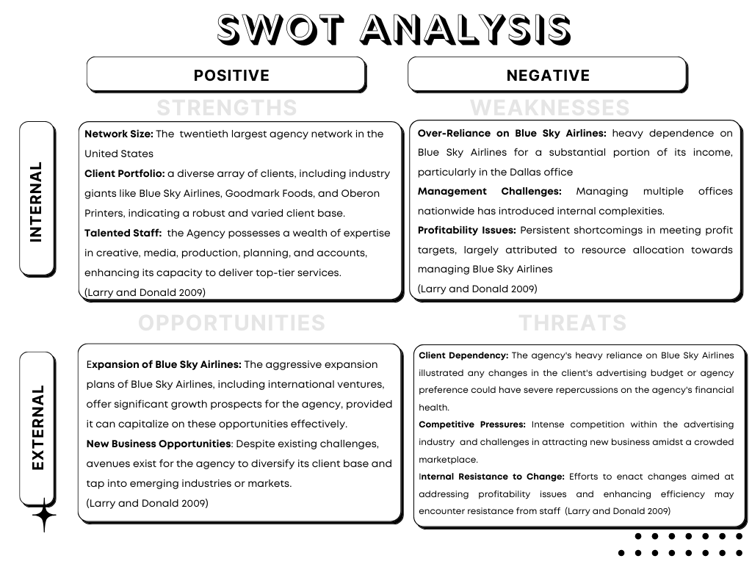
The SWOT analysis underscores an issue: the risk posed by an excessive dependence on a single client ( the agency's heavy reliance on Blue Sky Airlines). The insight here is the client base should be expanded within the same industry as the existing clients. The agency can leverage existing resources, such as a highly skilled workforce, presenting an opportunity to tap into new segments within the industry while simultaneously augmenting revenue streams for the Dallas office to meet its financial objectives.
2.1.2 Issue 2: Evaluation
The insight into diversifying the agency's client base within the same industry offers immediate benefits and long-term strategic advantages. Firstly, it addresses the pressing need to reduce the agency's dependence on a single client, mitigating the associated risks and fostering financial stability (Gridlex nd). By expanding the customer file, the agency opens up new income sources, bolstering its financial health. When expanding the customer base in the same industry, the agency can fully take advantage of staff with extensive experience and capacity to come up with the best strategies for new clients, with such efficiency, the agency can completely overcome threats such as client dependency and competitive pressure and at the same time, and providing the Dallas office with the opportunity to meet income goals. However, while this insight provides immediate relief, its long-term effectiveness hinges on continuous adaptation and innovation. In the long run, the agency must transition towards deeper client engagement strategies, such as customer retention measures, to sustain growth and capitalise on lucrative opportunities.By deepening engagement with clients the agency not only bolsters client retention but also taps into the lucrative potential highlighted by research indicating that engaged clients yield significantly higher revenue returns, a trend mirrored by engaged employees (John H F and Jim A, 2007). This shift towards long-term client engagement measures ensures the agency's resilience in the face of competitive pressure. In addition, for the entire advertising industry, this insight can be used temporarily by agencies facing similar situations.

2.1.3 Issue 3: Application

I can apply it in communication studies at university like doing my assignment about clients. Moreover, I can apply this knowledge in my internship or work experiences as an account manager. For example: I can use this analysis to develop strategies for diversifying their client base and implementing risk management measures to mitigate the impact of client fluctuations.

2.2: Gotham Media

2.2.1 Issue 1: Description
The issue at hand is around Kyle, a talented individual inside an agency who has a tendency to oversee and control every part of projects and handle everything himself based on his own thoughts, resulting in a loss of control and an overwhelming workload. The insight gleaned from this situation emphasises the importance of efficient delegation and trust in team members to handle responsibilities autonomously. Effective delegation not only reduces Kyle's workload, but it also encourages collaboration and inspires team members to flourish in their jobs. By distributing tasks effectively and trusting in the capabilities of the team, one can mitigate the risk of burnout, enhance efficiency, and promote a more cohesive and productive working environment.

2.2.2 Issue 2: Evaluation
This part will evaluate the effectiveness of delegation relating to the management skill. Management is about planning and budgeting, controlling and problem-solving, organising and staffing (Kotter 2001). Effective delegation is an essential component of effective project management in the field of communication initiatives. It serves as a litmus test for a manager's ability to trust their team, streamline workflows, and achieve project objectives efficiently. Delegation allows team members to take ownership of work, generating a sense of responsibility and accountability that promotes productivity and innovation (John U 2020). By distributing tasks based on individual strengths and expertise, managers can optimise resource allocation and ensure that project requirements are met with precision and timeliness (Zhen Xiong C and Samuel A 2007). Moreover, delegation cultivates a collaborative work culture, where team members are encouraged to share ideas, collaborate on solutions, and support one another in achieving common goals . However, the effectiveness of delegation hinges on clear communication, strategic planning, and ongoing support and guidance from managers (Scott S et al 2011). Without proper delegation, managers risk micromanagement, stifle creativity, and overwhelm team members, ultimately undermining project success as in the case study (Larry and Donald 2009). Therefore, mastering the art of delegation is paramount for managers overseeing communication projects, as it not only enhances project outcomes but also cultivates a dynamic and resilient team capable of navigating complex challenges and driving sustained success.

2.2.3 Issue 3: Application
I can apply the insight in my work as an account manager. I can delegate tasks by fostering a collaborative work environment where team members feel empowered to contribute their expertise and ideas, then lead to innovative solutions and strengthened client partnerships. In my communication studies at university, I can apply the insight of delegation by ensuring tasks within my study group are delegated equally, let the team members to discuss research specific topics or chapters or break down large assignments or projects into smaller tasks and delegate them among group members or classmates.

2.3: Vineyard Agency Case

2.3.1 Issue 1: Description

The problem comes with increased expenses and concerns about profitability and financial health. Especially regarding Tony Wright's spending habits, particularly in terms of high entertainment expenses and increased agency write-offs (Larry and Donald 2009). The CFO raised alarms about the impact of these expenditures on the agency's bottom line and overall financial health. This underscores the insight here is to cut off unnecessary fees especially on entertainment and the substantial write-offs, simultaneously discussing with Tony Wright to be responsible for these fees.

2.3.2 Issue 2: Evaluation

The reason why the unnecessary debt write-off and entertainment expenses were so high caused the company to lose a huge amount of money unnecessarily. Furthermore, cutting costs also helps the company use money to find new clients, who can help increase the agency's profits and finances. At the same time, the agency can completely use this source of money to retain old customers by creating client care services and offering highly effective development strategies for current clients, also known as increasing service quality to retain clients (Zeithaml, V.A., 2000). This insight also brings long-term efficiency because the company can compensate for capital deficits from unnecessary spending in the long run. In the long-term, this measure also helps the company bring steady increases in profits.

2.3.3 Issue 3: Application
I can apply this insight when working for an advertising agency as account managers by applying insights by scrutinising expenses, especially entertainment costs, and identifying areas for reduction. I suggest they collaborate with stakeholders to trim expenses without compromising service quality. Saved funds can then be directed towards client acquisition and retention efforts, enhancing service quality and ensuring client satisfaction. Additionally, I will prioritise value-based services, demonstrating the tangible benefits clients receive from agency investments. This shift away from unnecessary expenses towards value-driven approaches fosters client loyalty and improves overall agency performance.

3. Conclusions and recommendations
To conclude, the report highlights the significance of strategic decision-making in client management within the advertising industry by using the DEA method. Insights from the case studies emphasise the importance of diversifying client bases, effective delegation, and cutting unnecessary expenses to drive sustained success, optimise resource utilisation, and foster long-term growth and profitability. The recommendation here is to apply these insights in practice while exploring their long-term impacts and industry benchmarks by applying insights through a phased approach, gradually implementing. Then conducting small-scale pilot studies to assess short-term impacts while continuously monitoring long-term effectiveness and comparing performance against industry benchmarks for continuous improvement.

4. References:

1. Jhon U (2020) ‘Effective Delegation and Its Impact on Employee Performance’, International Journal of Economics and Business Administration,6: 78-87

2. Zhen Xiong C and Samuel A (2007) ‘Delegation And Employee Work Outcomes: An Examination Of The Cultural Context Of Mediating Processes In China’, Academy of management journal, 50(1): 226-238

3. Scott S, Gang W and Stephen HC (2021) ‘Antecedents and Consequences of Psychological
and Team Empowerment in Organisations: A Meta-Analytic Review’, Journal of Applied Psychology 96(5):981-1003. DOI:10.1037/a0022676

4. Kotter 2001, Kotter, J. P., (2001), Leadership Perspectives: What leaders really do?, Routledge, doi: 10.4324/9781315250601

5. Gridlex (n.d). Client Dependency: Risks of Overreliance on Key Advertising Client, Gridlex website, accessed 12 Apr. 2024. https://gridlex.com/a/risks-of-overreliance-on-key-advertising-clients-st7687/?utm_source=gAAAAABmH7CtyFp7UlmslKuxxfIc7qxZRHvPo3oe9xuh8_wlbFxwDszMjxDDxOlU1_7hvgnGGuWRVdkr9sBlX3KdRVmCCfoECA==

6. John H F and Jim A (2007), Human Sigma: Managing the Employee-Customer Encounter, Gallup Press.

7. Zeithaml, V.A. (2000), ‘Service quality, profitability, and the economic worth of customers: what we know and what we need to learn’, Journal of the academy of marketing science, 28:.67-85, doi: 10.1177/0092070300281007

8. Larry and Donald (2009), Cases in Advertising Management, Routledge, doi: 10.4324/9781315705934

